**GCSI Procedure Room Recording System Instructions for Use**

**Introduction:**

This document provides a detailed overview of how different user groups should utilize the GCSI Procedure Room Recording System. The structure of these instructions is as follows:

* Section 1: Administrators (GCSI technicians) - before student recording, one-time set up (~10 min)
* Section 2: Administrators (GCSI technicians) - before student recording, subsequent set up (~2 min)
* Section 3: Administrators (GCSI technicians) - after student recording (~2 min)
* Section 4: Administrators (GCSI technicians) - troubleshooting tips
* Section 5: Students
* Section 6: Facilitators

**Features:**

The Recording System has the following features:

* Requires minimal input from students to record and save videos.
* Allows students to modify camera setup for different procedures.
* Saves video recordings as .mp4 for simple playback on most video players.
* Uses OBS Studio to allow for multiple camera angle streams.
* Automatically names video files using students’ information for easy sorting by administrators.
* Automatically deletes video recordings and student information from local storage after video is saved (prevents PII access between students).
* Automatically encrypts saved videos using 7-Zip, extractable only by administrators (prevents PII access between students).

**Materials:**

To use the Recording System, you will need the following:

* Computer with access to the Internet
* Multiple camera sources (webcams, iPads, etc.)

**Section 1: Administrators (GCSI technicians) - before student recording, one-time set up (~10 min)**

**Introduction:**

This section provides instructions for administrators (GCSI technicians) on setting up the recording system on a PC for the first time. These steps will be performed **only once**, unless a factory reset occurs on the PC or the PC is switched out for a new one.

**Step 1: Open Windows administrator account (see Figure 1)**

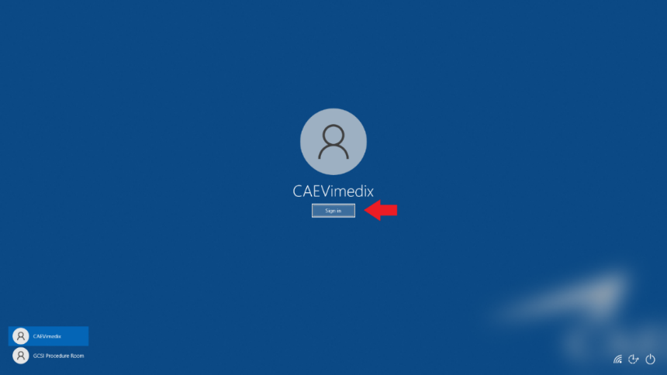

*Figure 1*: Windows administrator account sign-in

**Step 2: Download 7-Zip to computer C-Drive (C:\Program Files)**

Search for “7-Zip” on Google (see Figure 2) and download the installer (see Figure 3).

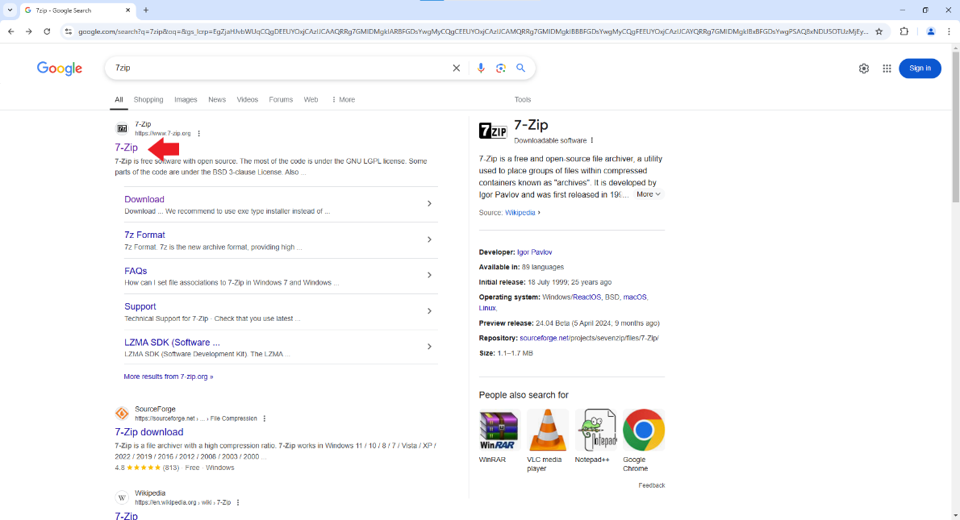

*Figure 2*: Google search for 7-Zip

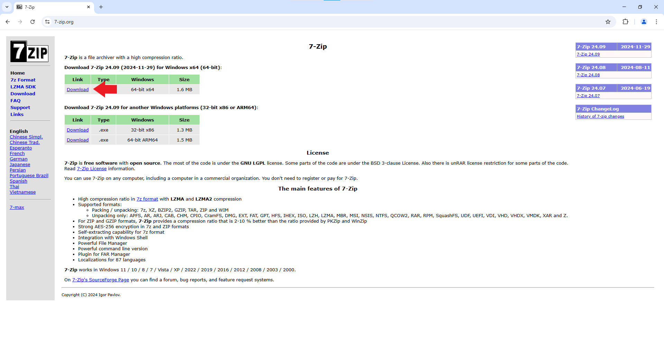

*Figure 3*: 7-Zip download link

Install 7-Zip (see Figure 4). Ensure destination folder is “C:\Program Files\7-Zip” (see Figure 5).

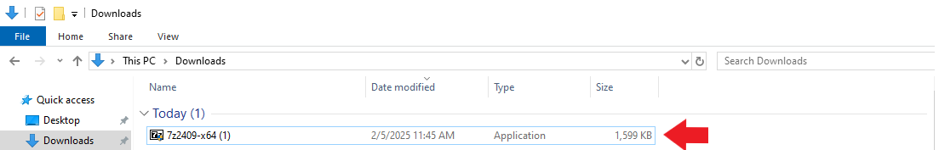

*Figure 4*: Double-click to open 7-Zip installer

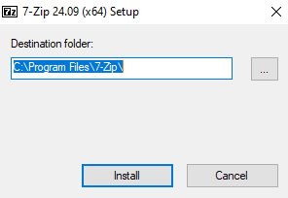

*Figure 5*: 7-Zip installer destination folder

**Step 3: Set up necessary folders in File Explorer**

Create the following **THREE** folders in File Explorer:

* Open the computer C-Drive by selecting “This PC”, then “OS(C:)” from the navigation pane in File Explorer. Create folder “**C:\GCSI Procedure Room Downloads**” (student recordings will be saved in this folder) directly in the computer C-Drive (see Figure 6).

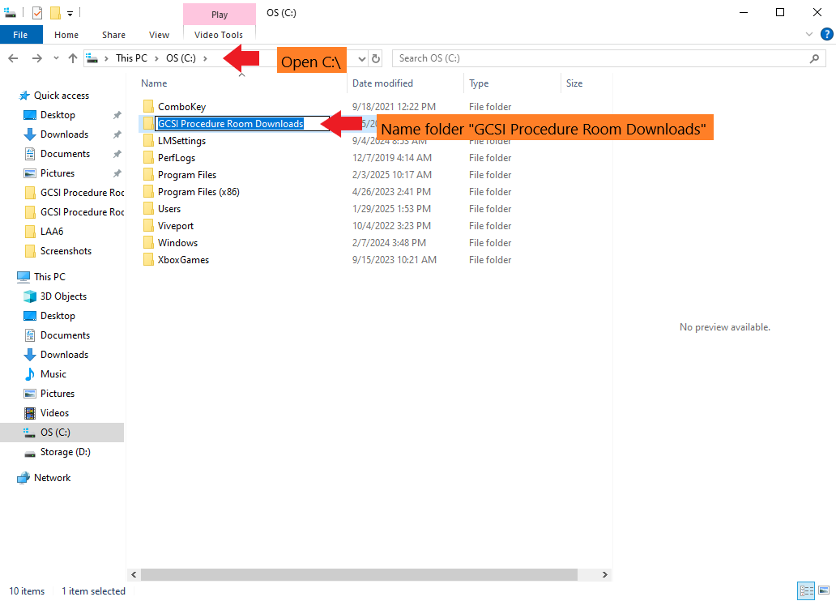

*Figure 6*: Create folder “C:\GCSI Procedure Room Downloads”

* Open the computer C-Drive by selecting “This PC”, then “OS(C:)” from the navigation pane in File Explorer. Create folder “**C:\Encrypted GCSI Procedure Room Downloads**” (encrypted student recordings will be saved in this folder, students will not be able to view files in this folder) directly in the computer C-drive (see Figure 7).

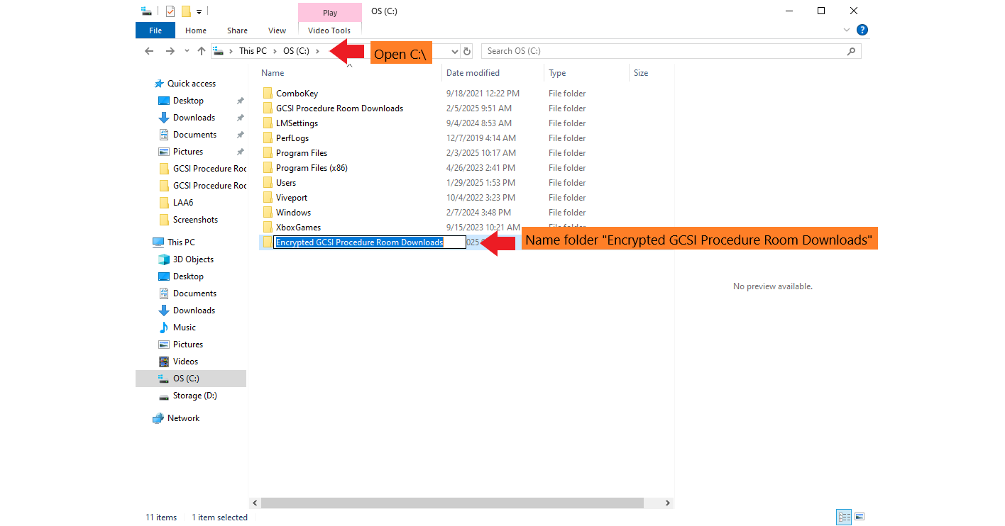

*Figure 7*: Create folder “C:\Encrypted GCSI Procedure Room Downloads”

* Exit the C-drive and open the administrator’s local document storage. Create folder “**GCSI Procedure Room Encryption PowerShell**” anywhere in administrator’s local document storage, **but not directly in the C-Drive** (so that a student using a Windows guest account cannot access) (see Figure 8).

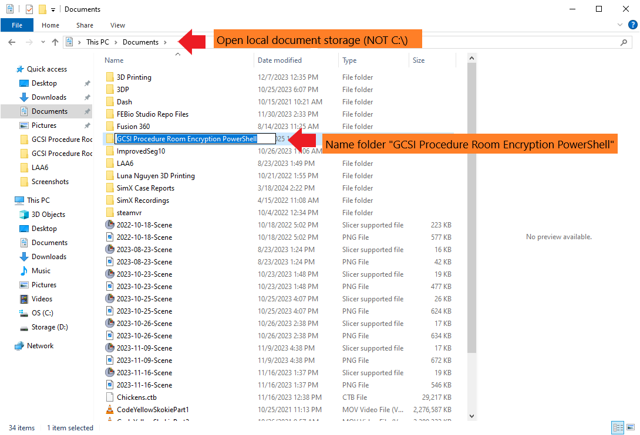

*Figure 8*: Create folder “GCSI Procedure Room Encryption PowerShell” in local documents

**Step 4: Set up PowerShell script for encryption of student recordings**

Navigate to <https://github.com/jchen6589/procedure-room-recording-v4> (see Figure 9). Download the “real_time_encrypt.ps1” file to your computer (see Figure 10).

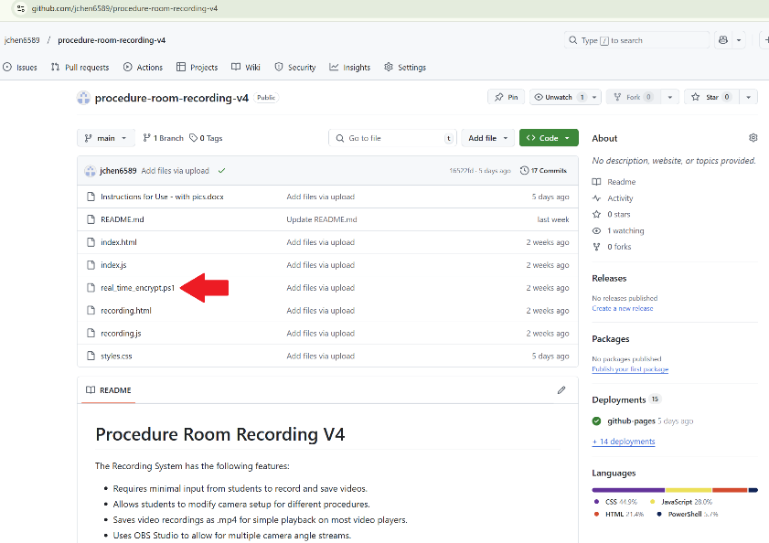

*Figure 9*: Select “real_time_encrypt.ps1” from GitHub homepage

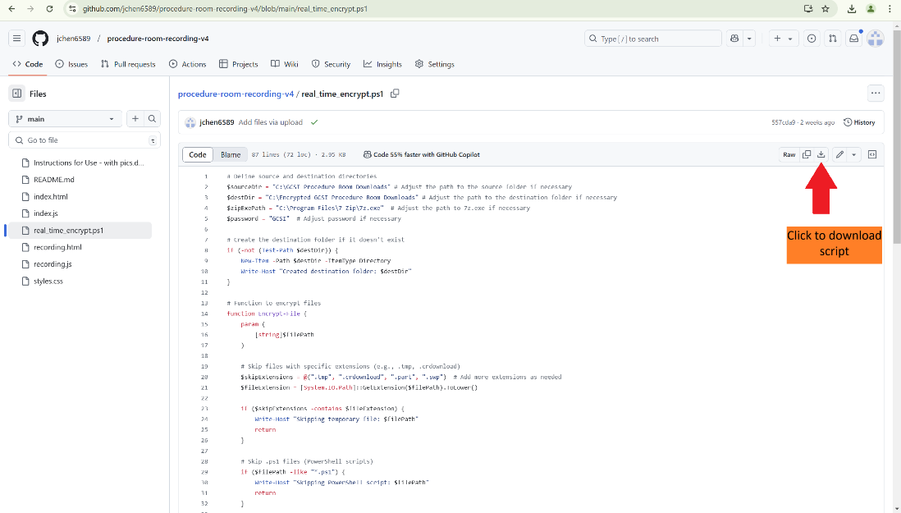

*Figure 10*: Download “real_time_encrypt.ps1”

Move the “real_time_encrypt.ps1” file to the “GCSI Procedure Room Encryption PowerShell” folder you just created in Step 2.

* If necessary, open “real_time_encrypt.ps1” in Notepad to adjust the password and the path to the source folder (for students to directly upload videos to), the destination folder (where encrypted files will go), and 7z.exe. However, if folder names and locations are created exactly according to the previous steps, no adjustment should be necessary (see Figure 11).

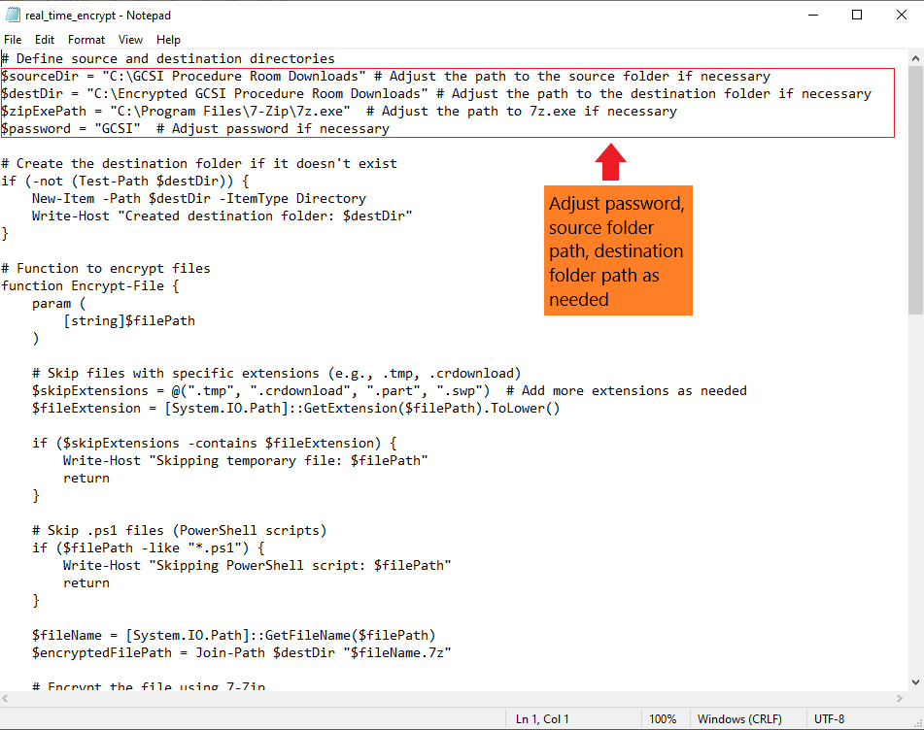

*Figure 11*: Create “real_time_encrypt.ps1” file in the “GCSI Procedure Room Encryption PowerShell” folder

Create a desktop shortcut to manually start the “real_time_encrypt.ps1” script (see Figures 12 and 13).

* Go to the computer Desktop, right-click anywhere on the Desktop, select “New”, and select “Shortcut”. For the location of the item, write the following:

**C:\Windows\System32\WindowsPowerShell\v1.0\powershell.exe -ExecutionPolicy Bypass -NoExit -File "C:\Users\CAEVimedix\Documents\GCSI Procedure Room Encryption PowerShell\real_time_encrypt.ps1"**

*Note: The text within the quotation marks provides the path to the “real_time_encrypt.ps1” script. Depending on where you saved the script, you may need to adjust this text within the quotation marks to match the actual path to “real_time_encrypt.ps1”.

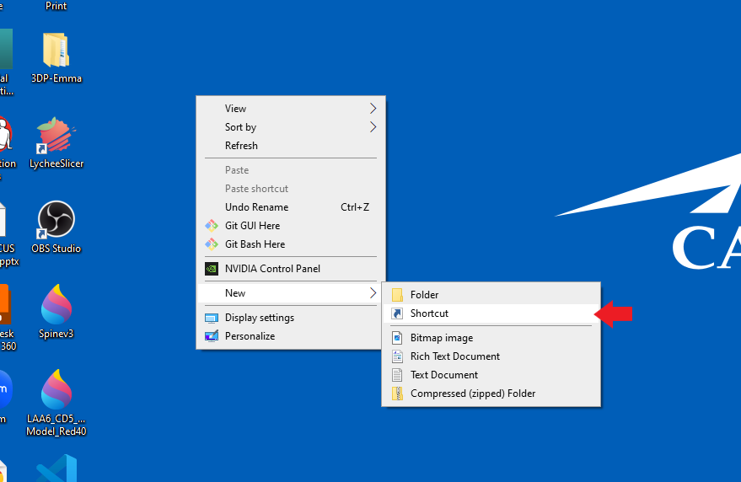

*Figure 12*: Create new shortcut on computer Desktop

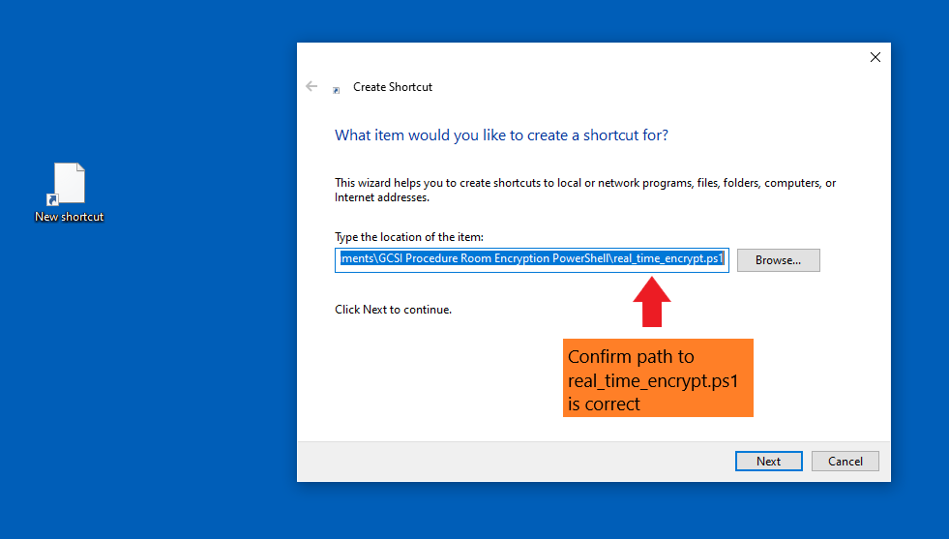

*Figure 13*: Set shortcut location as C:\Windows\System32\WindowsPowerShell\v1.0\powershell.exe -ExecutionPolicy Bypass -NoExit -File "C:\Users\CAEVimedix\Documents\GCSI Procedure Room Encryption PowerShell\real_time_encrypt.ps1"

* For the shortcut name, write “Start Real Time Encrypt” (see Figure 14).

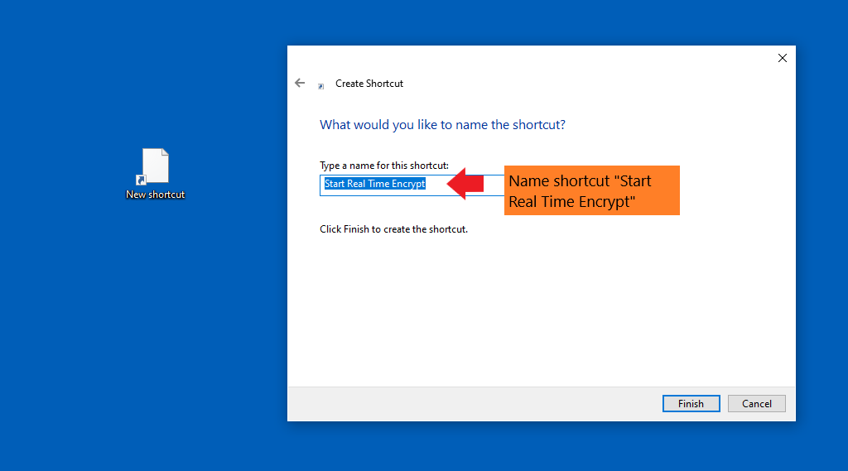

*Figure 14*: Set shortcut name as “Start Real Time Encrypt”

Double-click the shortcut to start running the “real_time_encrypt.ps1” script (see Figure 15). **Do not close the PowerShell window that opens.** This shortcut allows manual startup of the “real_time_encrypt.ps1” script (if desired, it is possible to configure the “real_time_encrypt.ps1" PowerShell script to start automatically on bootup, but manual start is used here to provide more user control).

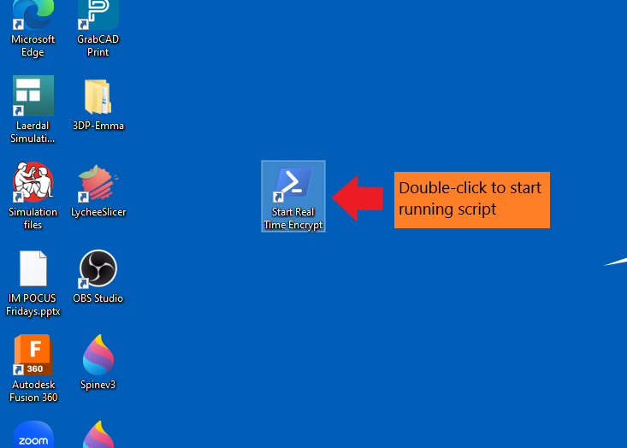

*Figure 15*: Start running “real_time_encrypt.ps1" script

**Step 5: Close Windows administrator account and create a Windows standard account (non-administrator)**

Create a Windows standard account (with limited access to Windows controls):

* Go to computer settings and click on “Accounts.”
* Navigate to “Family and Other Users.”
* Click on “Add Someone else to this PC.”
* Click on “The person I want to add doesn’t have an email address.”
* Click on “add a user without a Microsoft Account.”
* Enter your desired name for the account (e.g., GCSI Procedure Room) and leave the password section blank and click on “Next.”

Open Windows standard account by clicking on the Windows Start menu, clicking the account icon, and selecting the desired Windows standard account (see Figures 16-18):

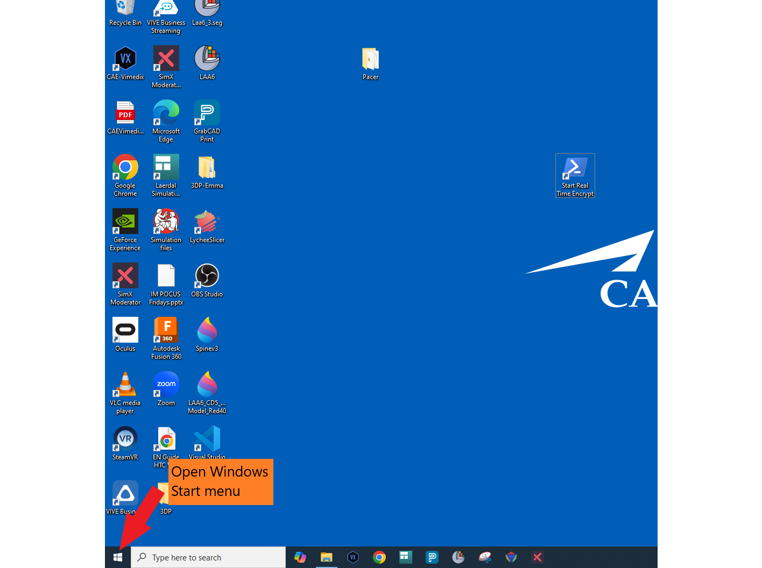

*Figure 16*: Open Windows Start menu

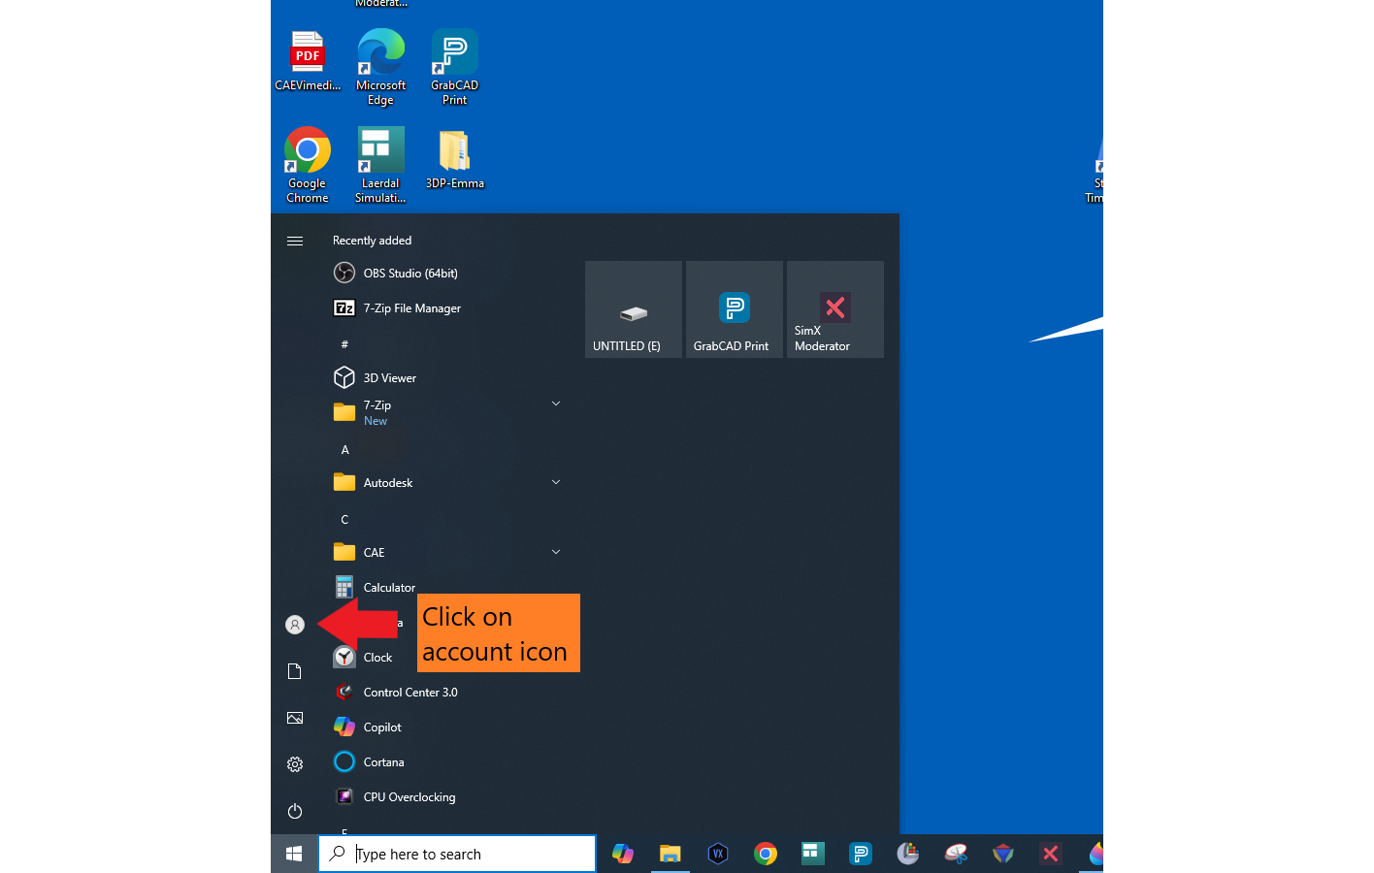

*Figure 17*: Click on account icon

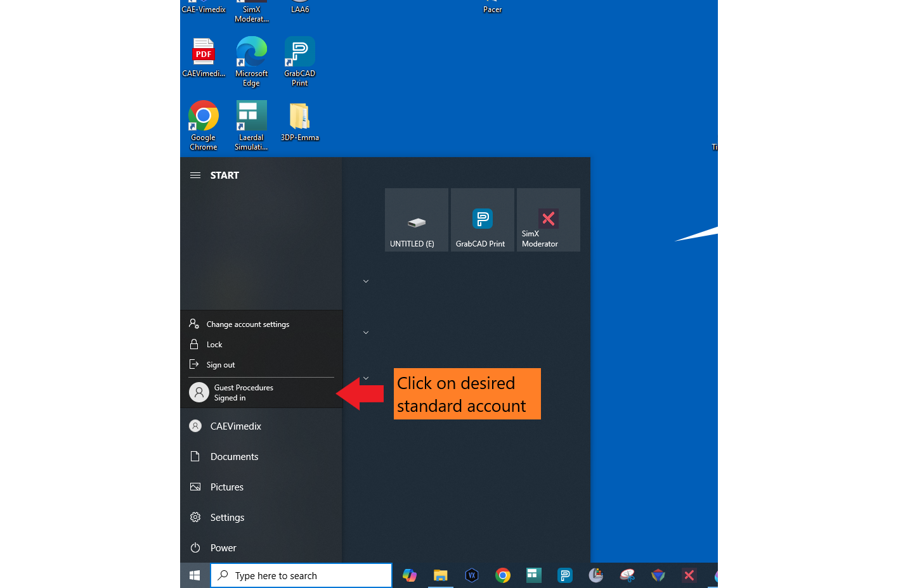

*Figure 18*: Select standard account

**Step 6: Download OBS Studio**

Search for “OBS” on Google and download the installer. Install OBS (see Figure 19). The location for installation does not matter.

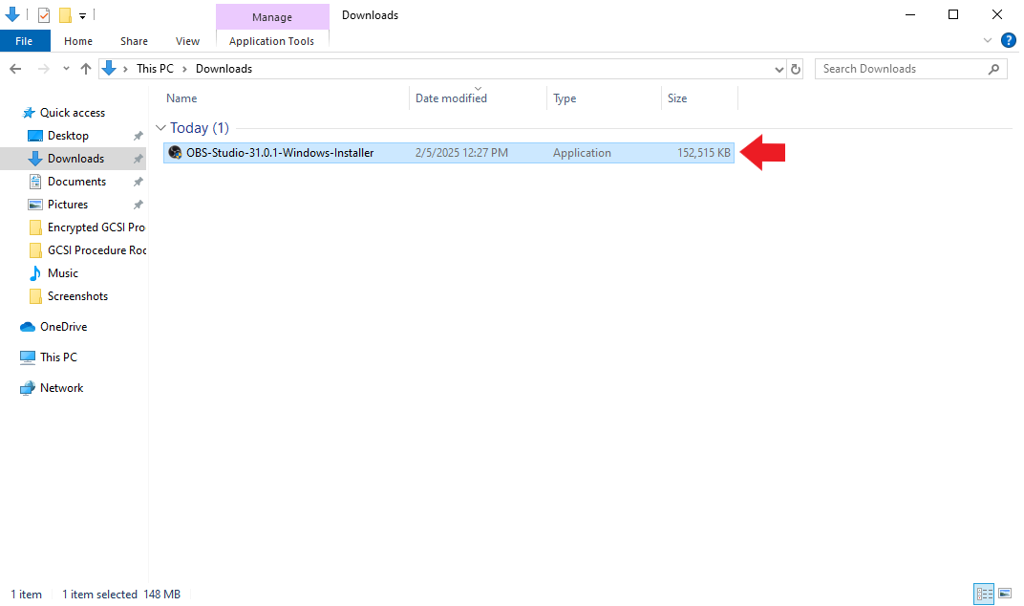

*Figure 19*: Double-click to install OBS Studio

**Step 7: Set up OBS Studio Virtual Camera**

Using OBS virtual camera will allow students to record multiple camera angles at once. Open OBS Studio from the Desktop (see Figure 20).

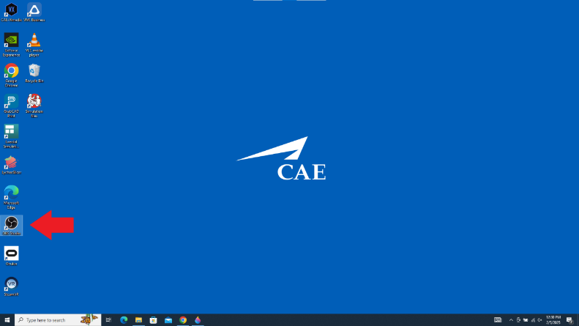

*Figure 20*: Open OBS from Desktop

Connect webcams to OBS:

* Locate “Sources”, select “+” to add sources, select “Video Capture Device”, and create a new video source (see Figures 21-23).

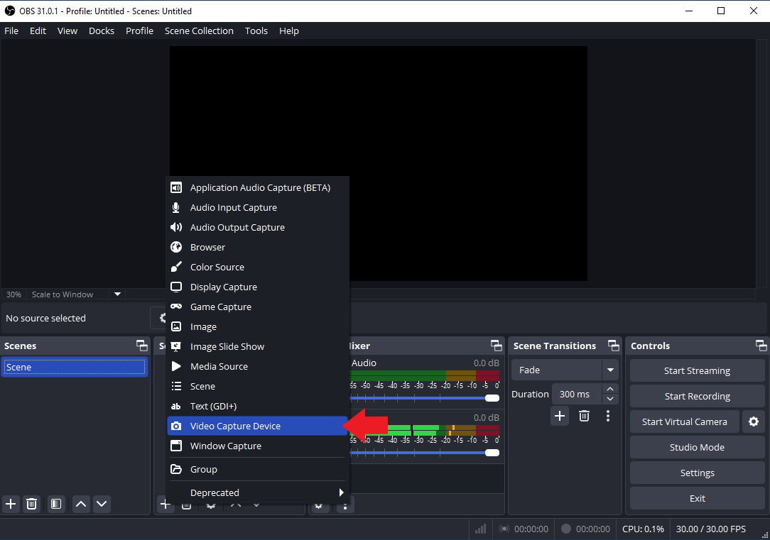

*Figure 21*: Create a Video Capture Device

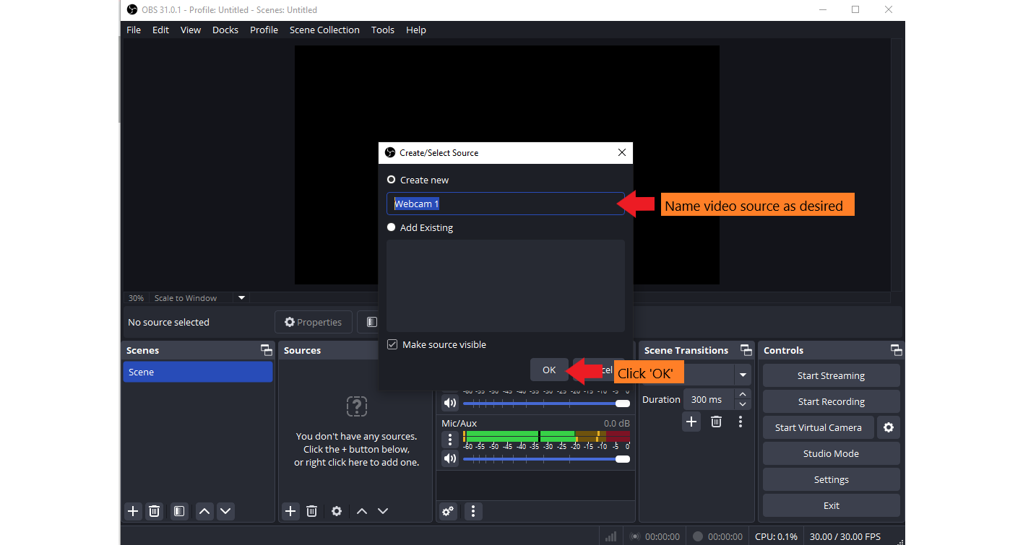

*Figure 22*: Create new video source

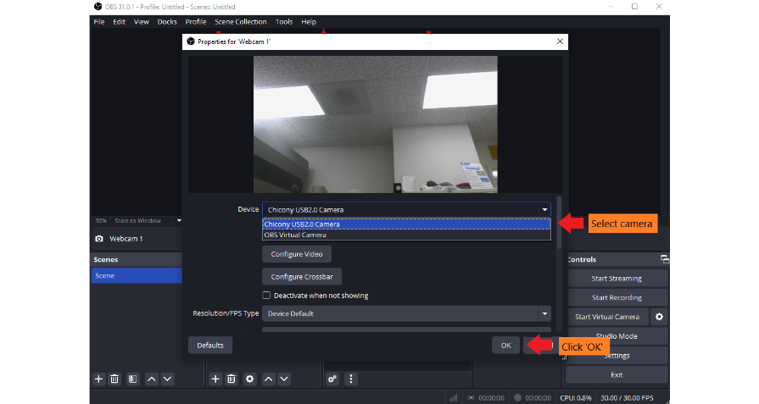

*Figure 23*: Select video source

* Orient webcam streams in the scene as desired (see Figure 24).

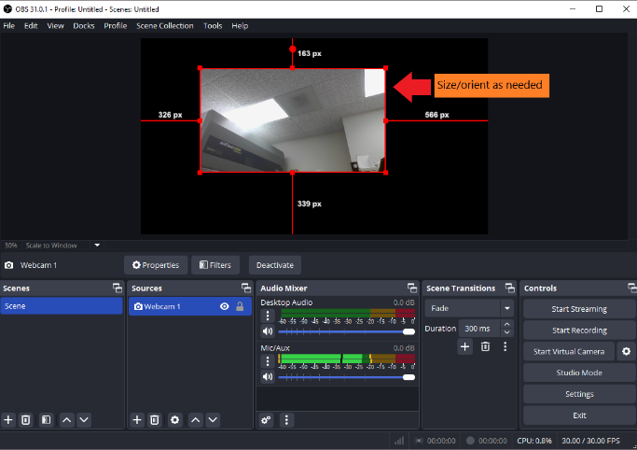

*Figure 24*: Size/orient webcam stream

* Add a text box for each camera stream and place it next to each stream to identify them. Locate “Sources”, select “+” to add sources, select “Text (GDI+)”, and create a new text source (see Figures 25-28).

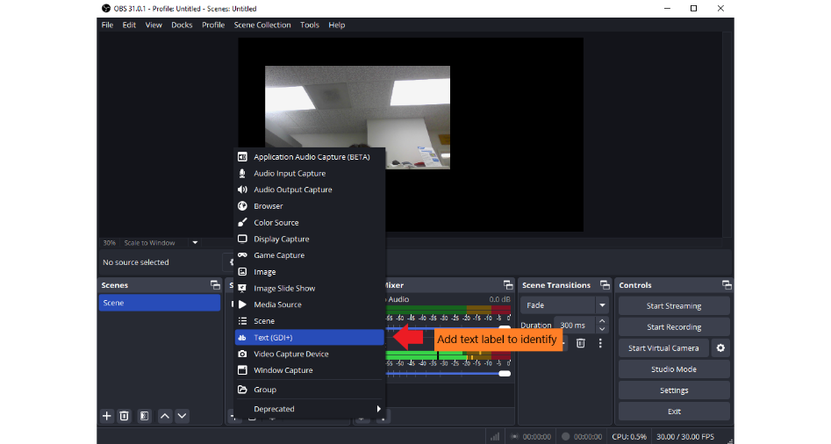

*Figure 25*: Create a Text label

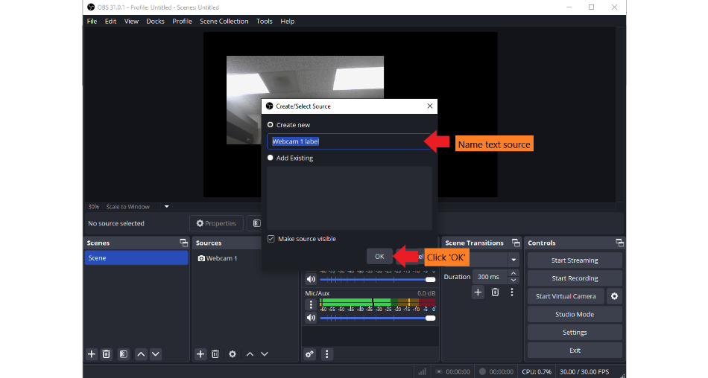

*Figure 26*: Create a new text source

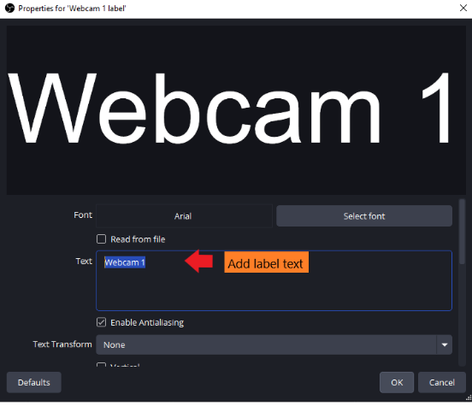

*Figure 27*: Add label text

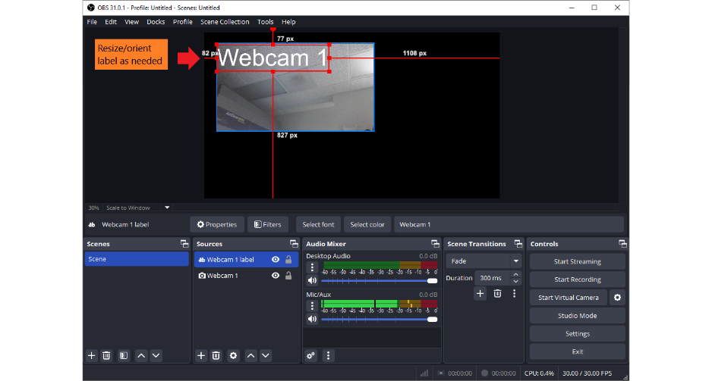

*Figure 28*: Size/orient text label

* Repeat for remaining webcams.

Click “Start Virtual Camera” (see Figure 29).

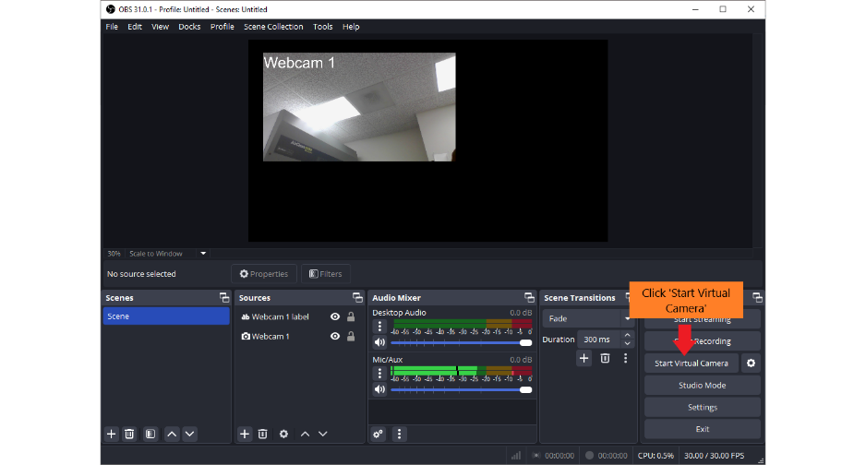

*Figure 29*: Start OBS Virtual Camera

If desired, you may also wirelessly connect iPad cameras to OBS (otherwise, skip to **Step 8**).

* Open Safari on an iPad and navigate to <https://vdo.ninja/>. Select “Add Your Camera to OBS” and select “Start” (see Figures 30 and 31).

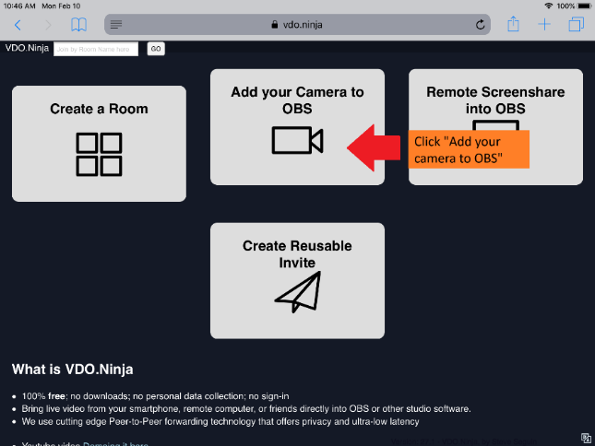

*Figure 30*: Open <https://vdo.ninja/> in iPad Safari and select “Add your camera to OBS”

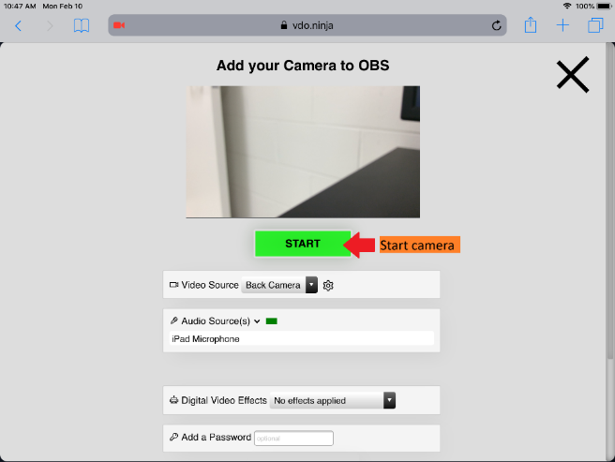

*Figure 31*: Start iPad camera

* Mute the iPad microphone (to prevent echo). Copy the unique VDO Ninja stream URL on the top of the page (see Figure 32).

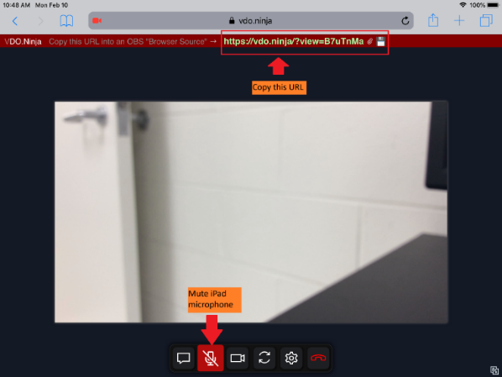

*Figure 32*: Mute iPad microphone and copy VDO Ninja URL

* Open OBS on your PC and locate “Sources”, select “+” to add sources, select “Browser”, and paste your VDO Ninja URL (see Figures 33-35).

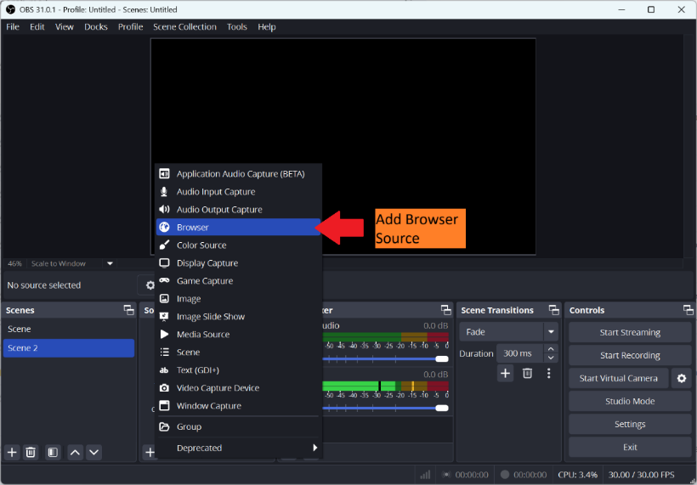

*Figure 33*: Add browser source

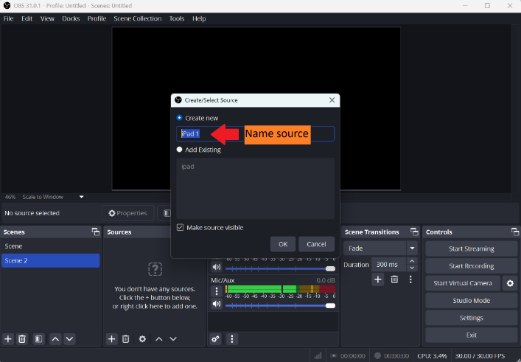

*Figure 34*: Name the browser source

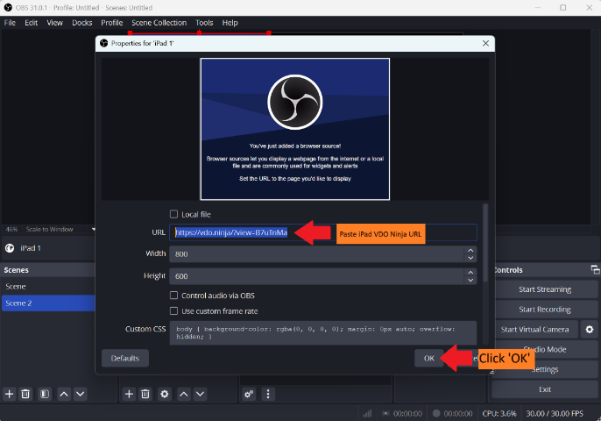

*Figure 35*: Paste iPad VDO Ninja URL to begin streaming

* Add a text box for each camera stream and place it next to each stream to identify them (see Figures 25-28 on page 13).

**Step 8: Set up browser for student use**

Open Chrome browser settings and navigate to “Privacy and security” (see Figure 36).

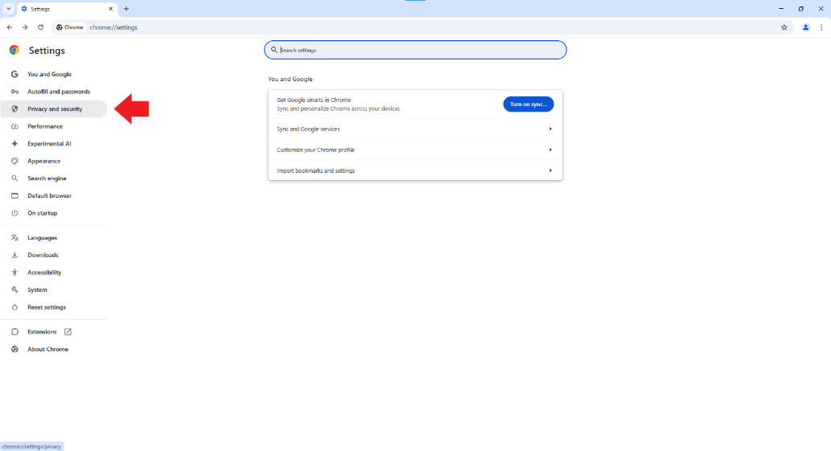

*Figure* 36: Open privacy/security settings

Select “Site Settings”, select “Camera”, set camera to “OBS virtual camera” (see Figures 37-39).

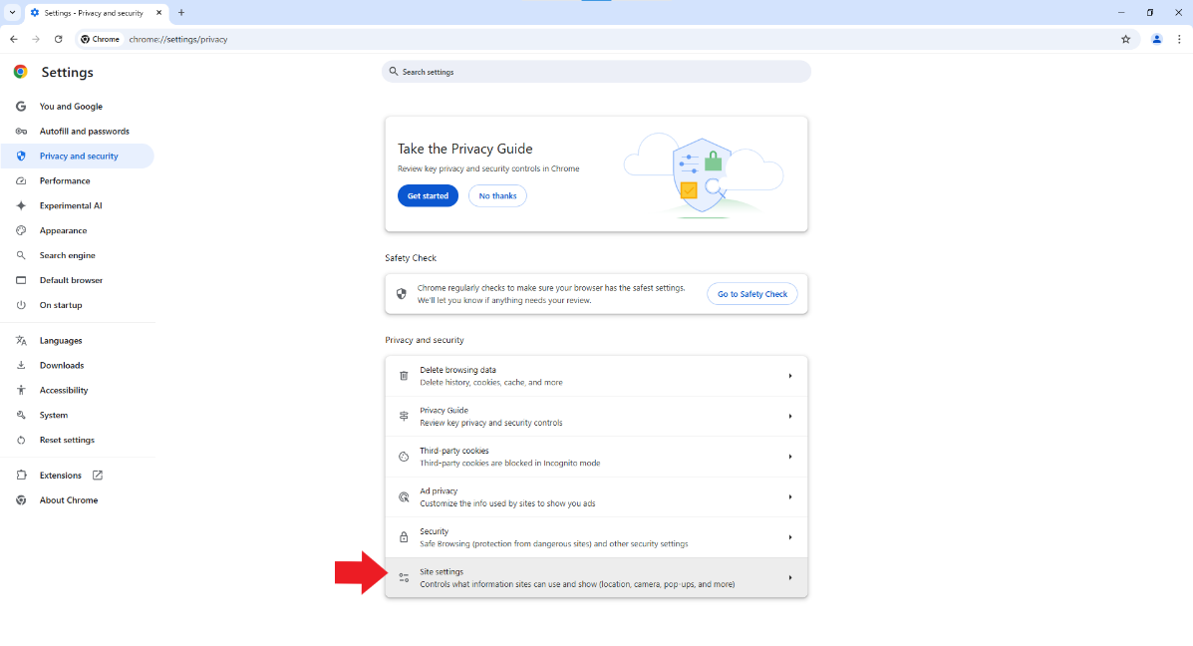

*Figure 37*: Open site settings

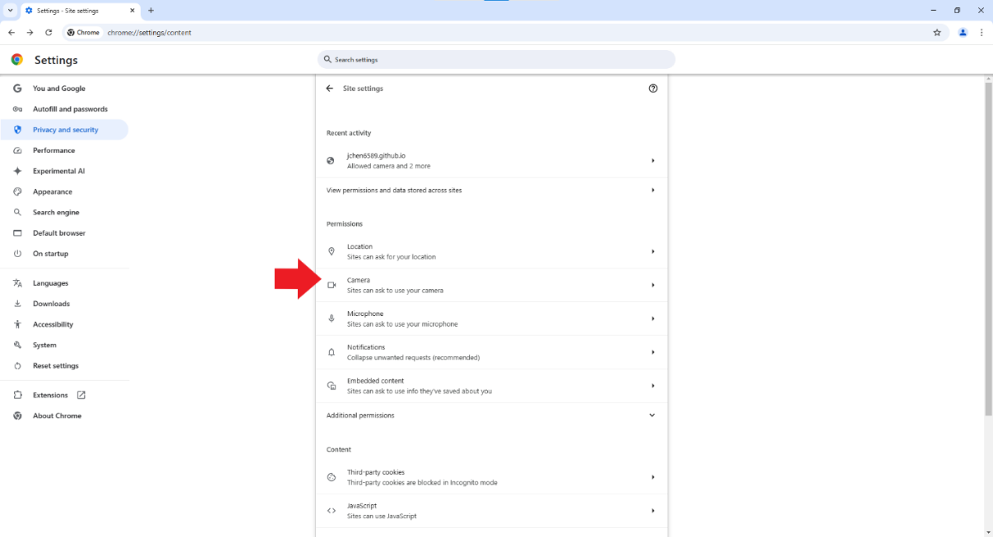

*Figure 38*: Open camera settings

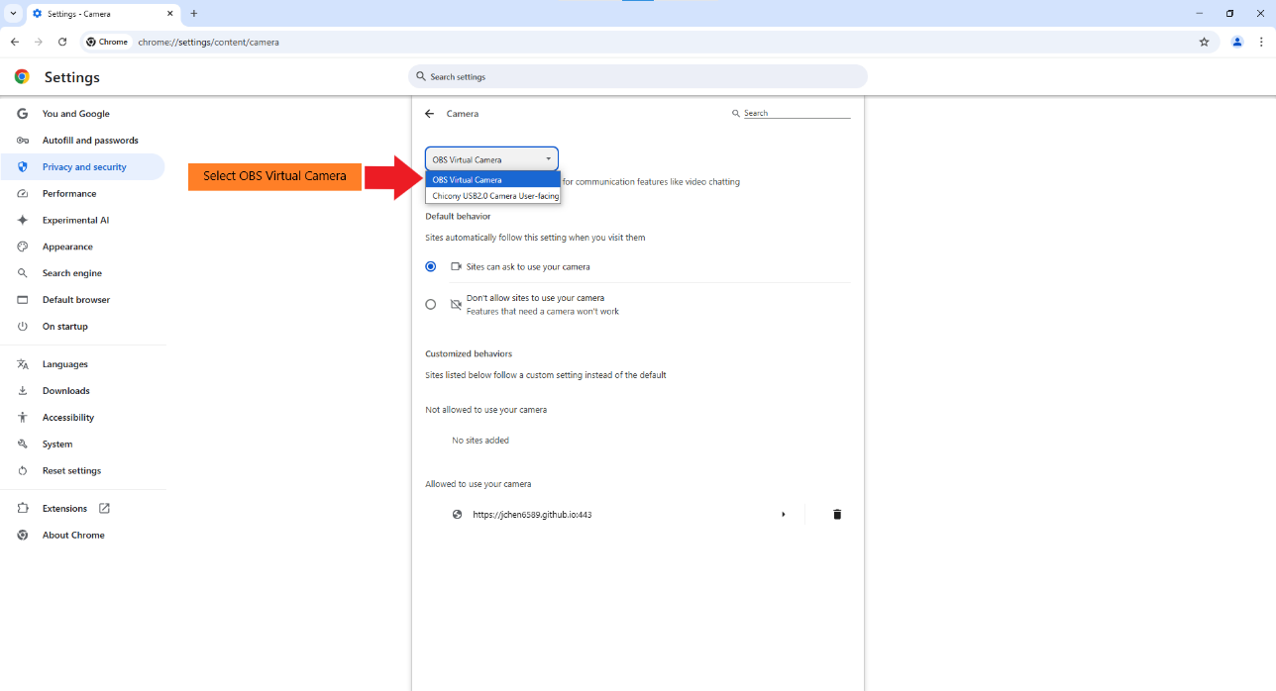

*Figure 39*: Select OBS Virtual camera

Open Downloads settings and set download folder to “C:\GCSI Procedure Room Downloads” (see Figures 40 and 41).

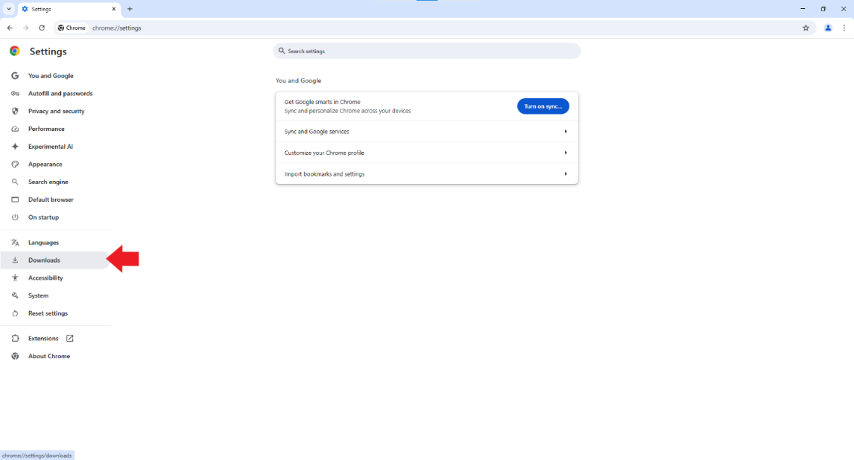

*Figure 40*: Open downloads settings

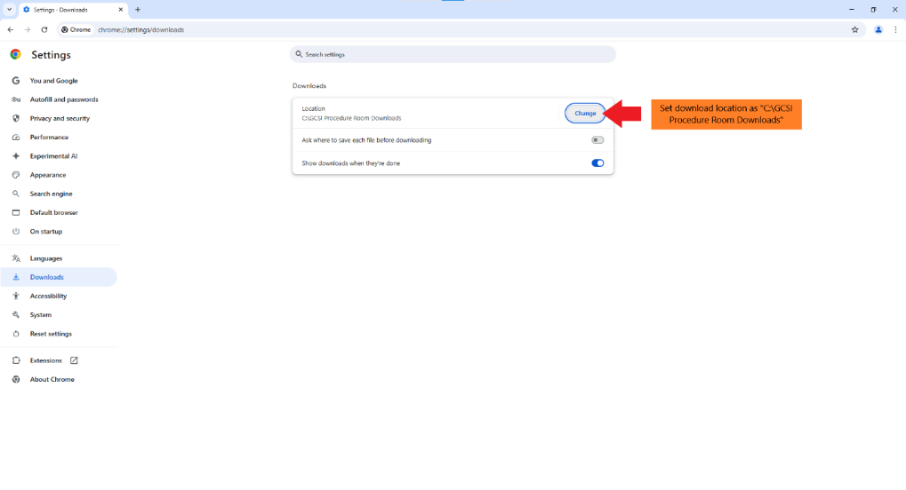

*Figure 41*: Set download folder to “C:\GCSI Procedure Room Downloads”

Open <https://jchen6589.github.io/procedure-room-recording-v4/> and leave the website on the start screen (see Figure 42). The system is now ready! Let’s get recording!

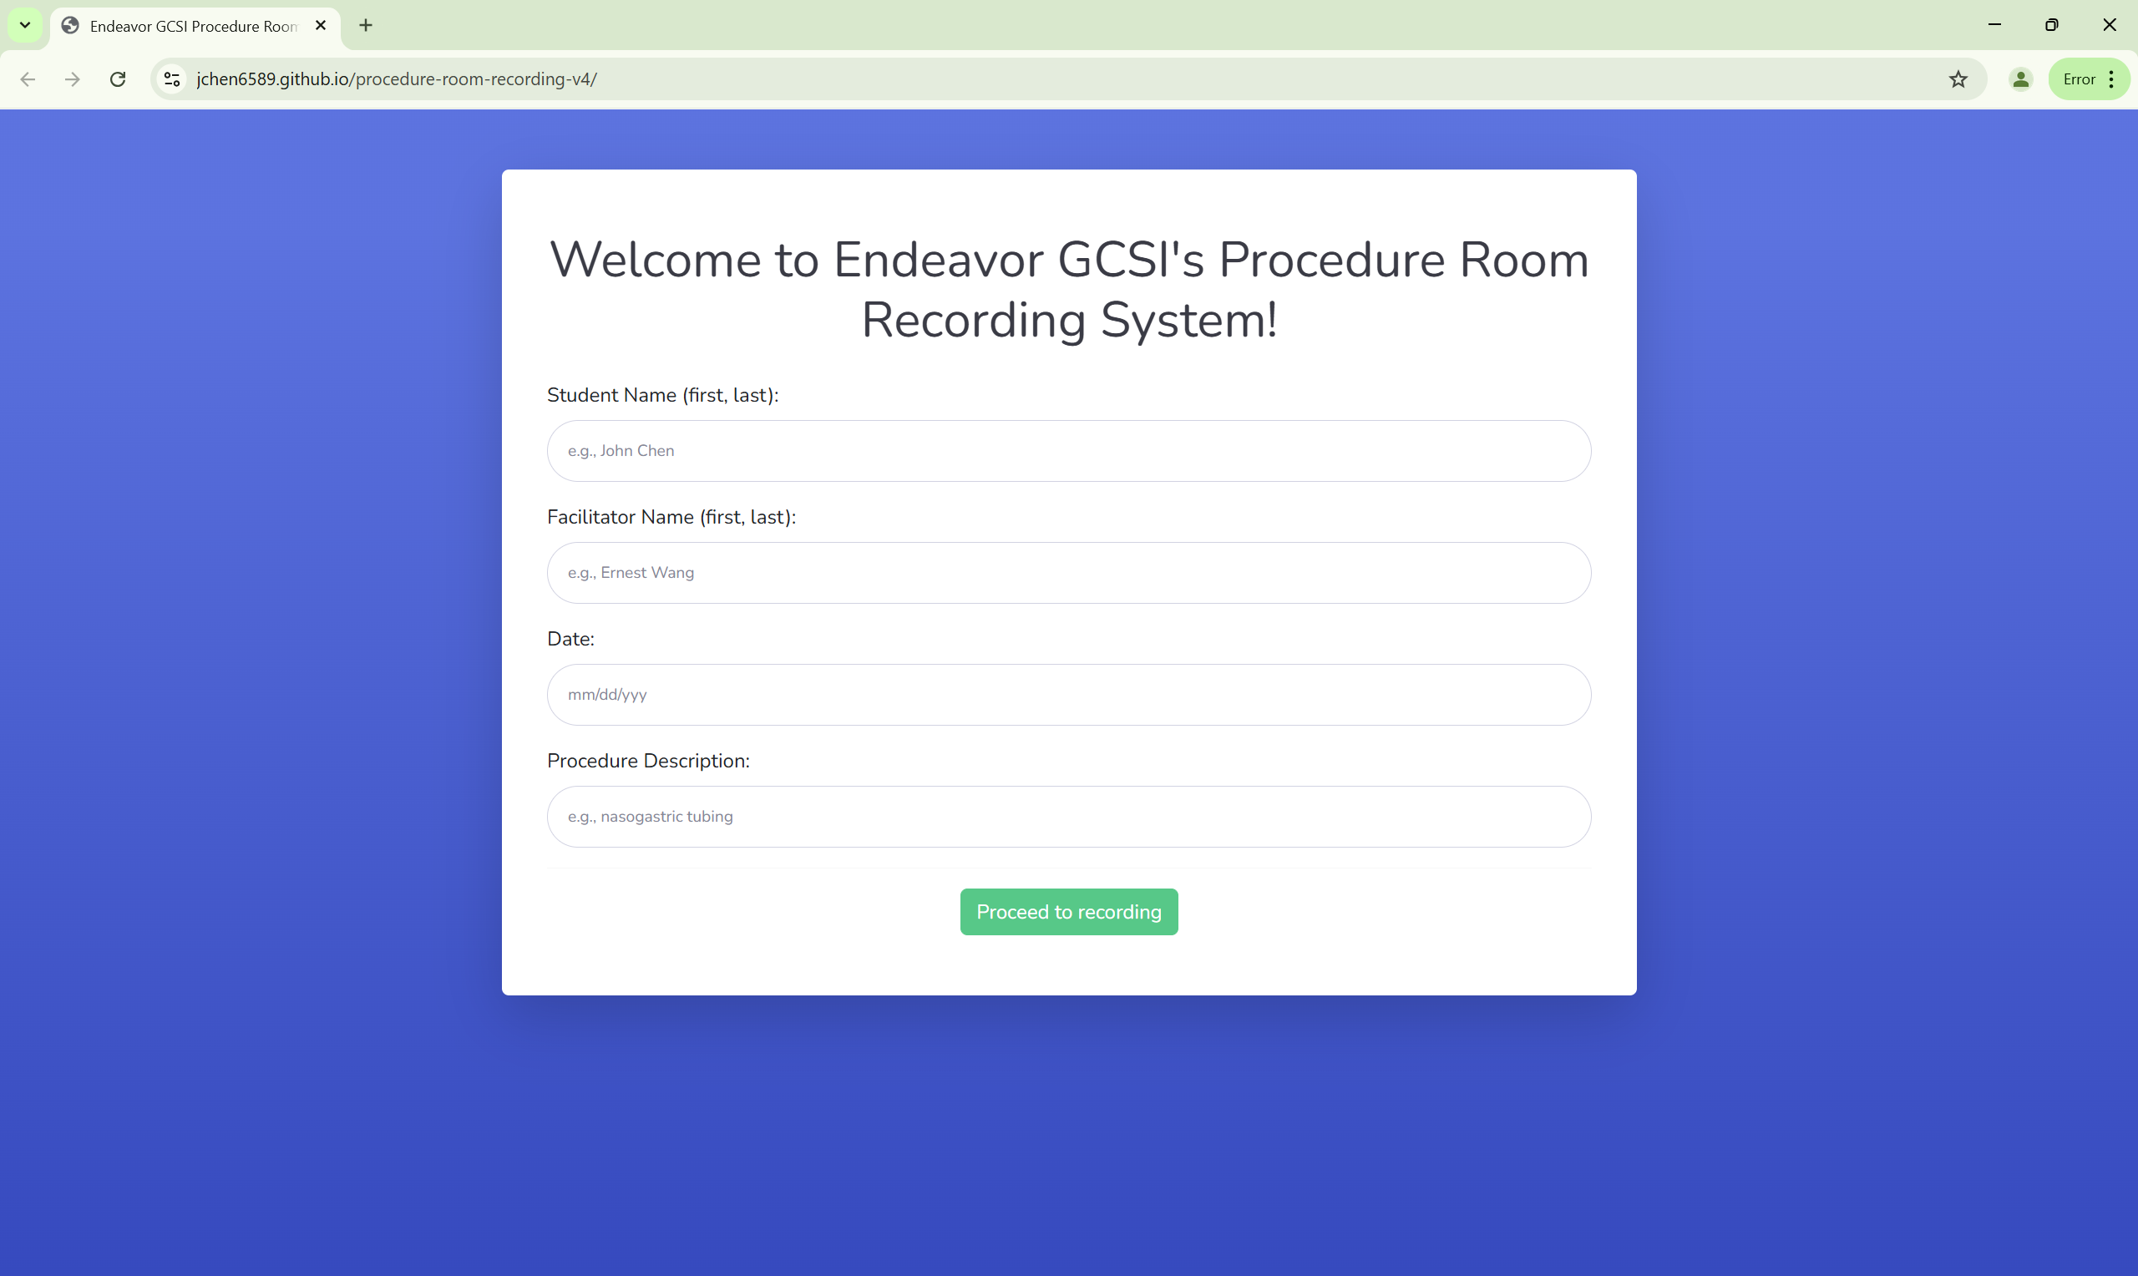

*Figure 42*: Procedure Room Recording System student screen

**Section 2: Administrators (GCSI technicians) - before student recording, subsequent set up (~2 min)**

**Introduction:**

This section should only be used after Section 1 is completed on your PC. It provides instructions for administrators (GCSI technicians) on setting up the recording system if the PC is ever shut down and applications must be reopened. If the PC is left awake at all times, the system can simply be left alone between students’ recording sessions unless problems are reported.

**Step 1: Open Windows administrator account (see Figure 43).**

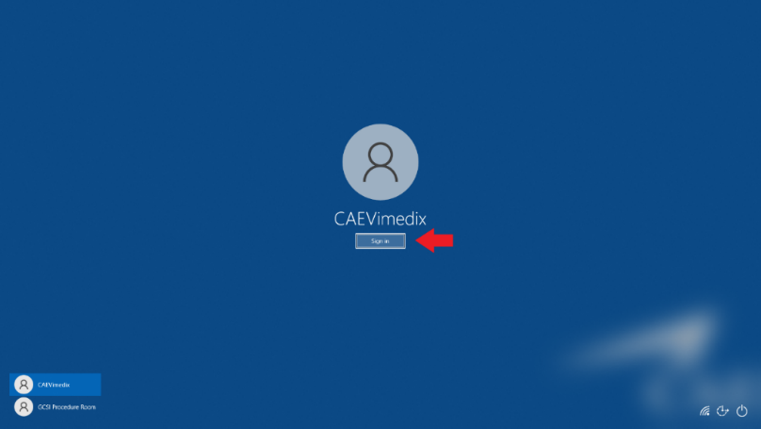

*Figure 43*: Windows administrator account sign-in

**Step 2: Start encryption PowerShell script**

Double click “Start Real Time Encrypt” shortcut to start running the “real_time_encrypt.ps1” script (see Figure 44). **Do not close the PowerShell window that opens**.



*Figure 44*: Start running script

**Step 3: Close Windows administrator account and open Windows standard account**

Open Windows standard account by clicking on the Windows Start menu, clicking the account icon, and selecting the desired Windows standard account (see Figures 45-47):



*Figure 45*: Open Windows Start menu

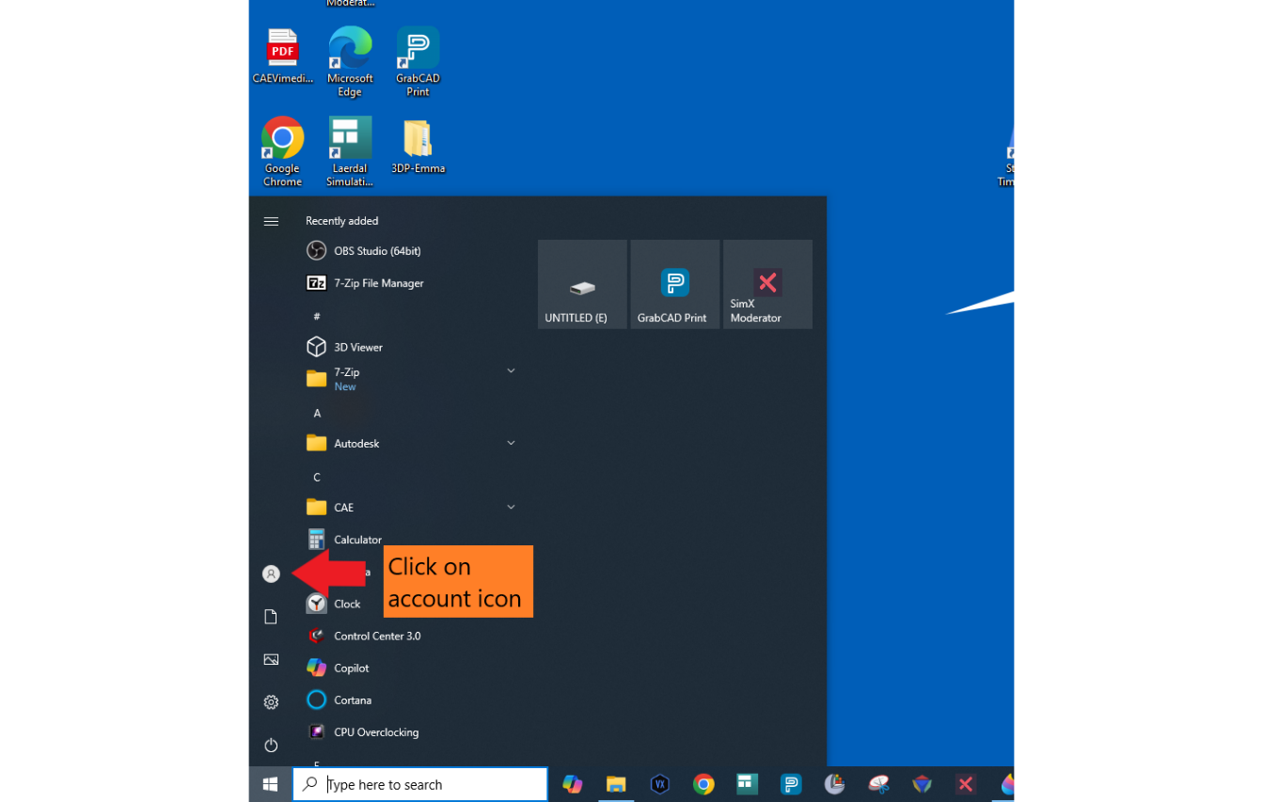

*Figure 46*: Click on account icon

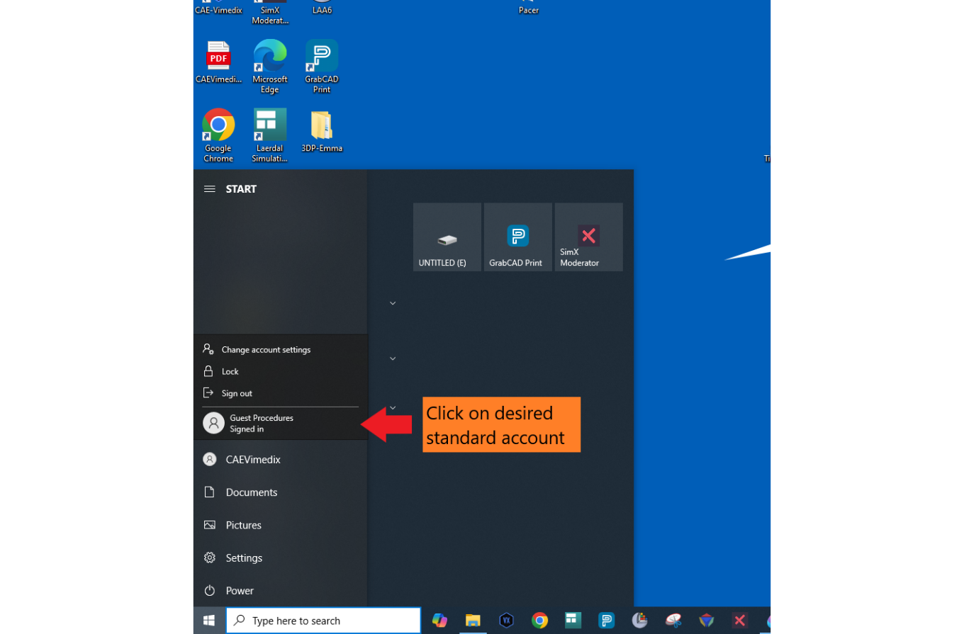

*Figure 47*: Select standard account

**Step 4: Start OBS Virtual Camera**

Open OBS Studio from the Desktop. Ensure all camera streams are running and labels are correct. **Click “Start Virtual Camera” in OBS** (see Figure 48).

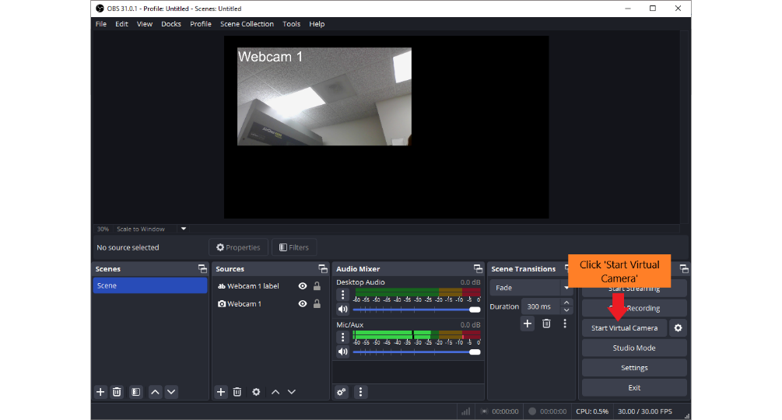

*Figure 48*: Start OBS Virtual Camera

**Step 5: Set up browser for student use**

Open Chrome window. Open privacy/security setting in Chrome window. Check that camera is set to "OBS virtual camera" (see Figure 49).

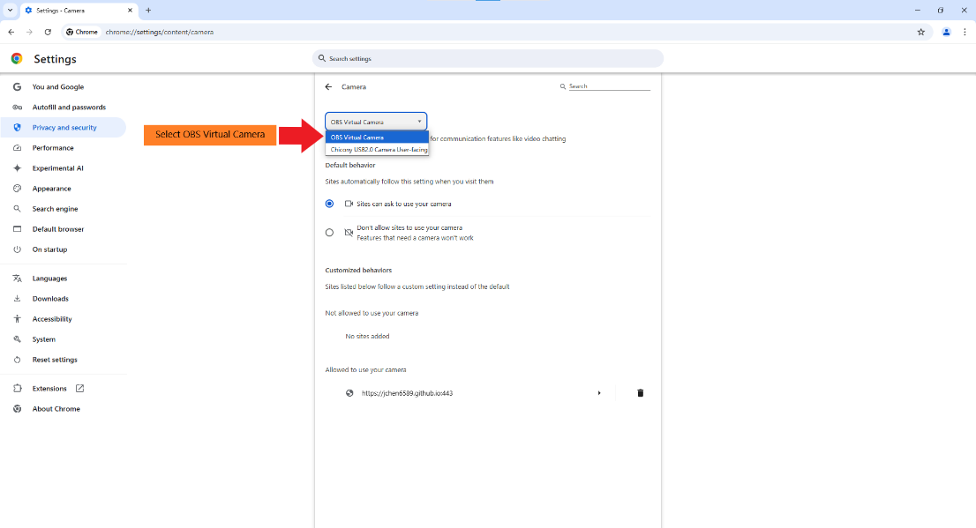

*Figure 49*: Select OBS Virtual camera

Open Downloads settings in Chrome window. Check that download folder is set to “C:\GCSI Procedure Room Downloads” (see Figure 50).

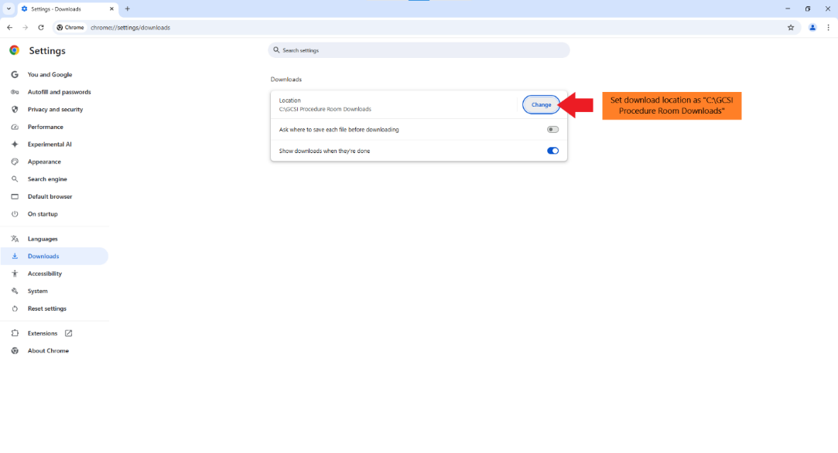

*Figure 50*: Set download folder to “C:\GCSI Procedure Room Downloads”

Open <https://jchen6589.github.io/procedure-room-recording-v4/> and leave the website on the start screen (see Figure 51). The system is now ready! Let’s get recording!



*Figure 51*: Procedure Room Recording System student screen

**Section 3: Administrators (GCSI technicians) - after student recording (~2 min)**

**Introduction:**

This section provides instructions for administrators (GCSI technicians) on retrieving encrypted student recordings to send to facilitators. This process can be completed as frequently as needed.

**Step 1: Open Windows administrator account (see Figure 52)**

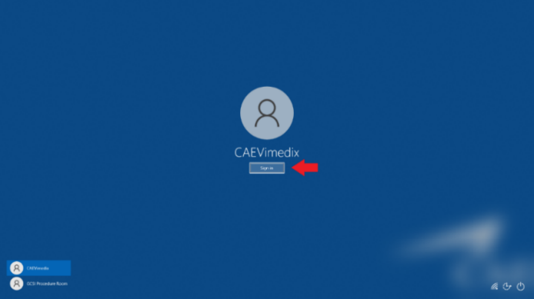

*Figure 52*: Windows administrator account sign-in

**Step 2: Extract encrypted student recordings\***

*Note: You can wait to the end of each day to unzip multiple students’ encrypted files together.

Open “C:\GCSI Procedure Room Downloads”. Confirm original files have been deleted (see Figure 53). This folder should be empty as long as the “real_time_encrypt.ps1” script is running.

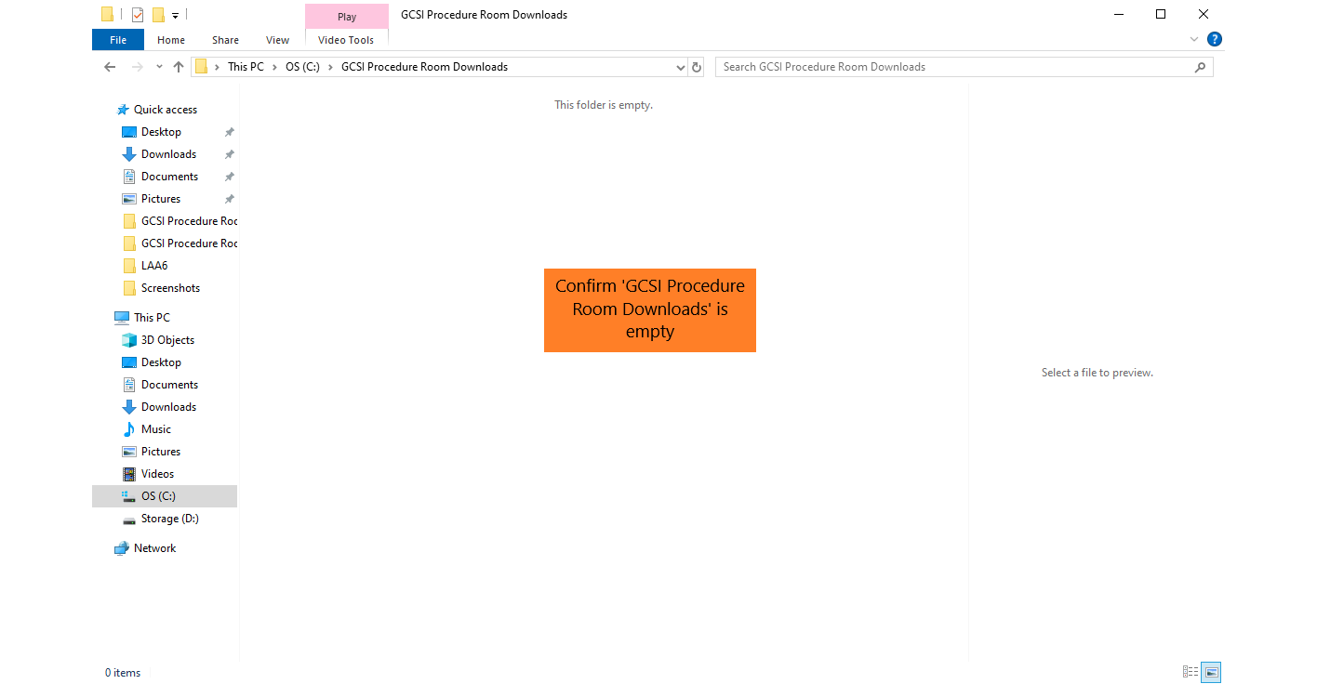

*Figure 53*: Confirm original student recordings have been deleted from “GCSI Procedure Room Downloads” folder

Unzip the encrypted files.

* Open “C:\Encrypted GCSI Procedure Room Downloads” and right click the encrypted files (see Figure 54).

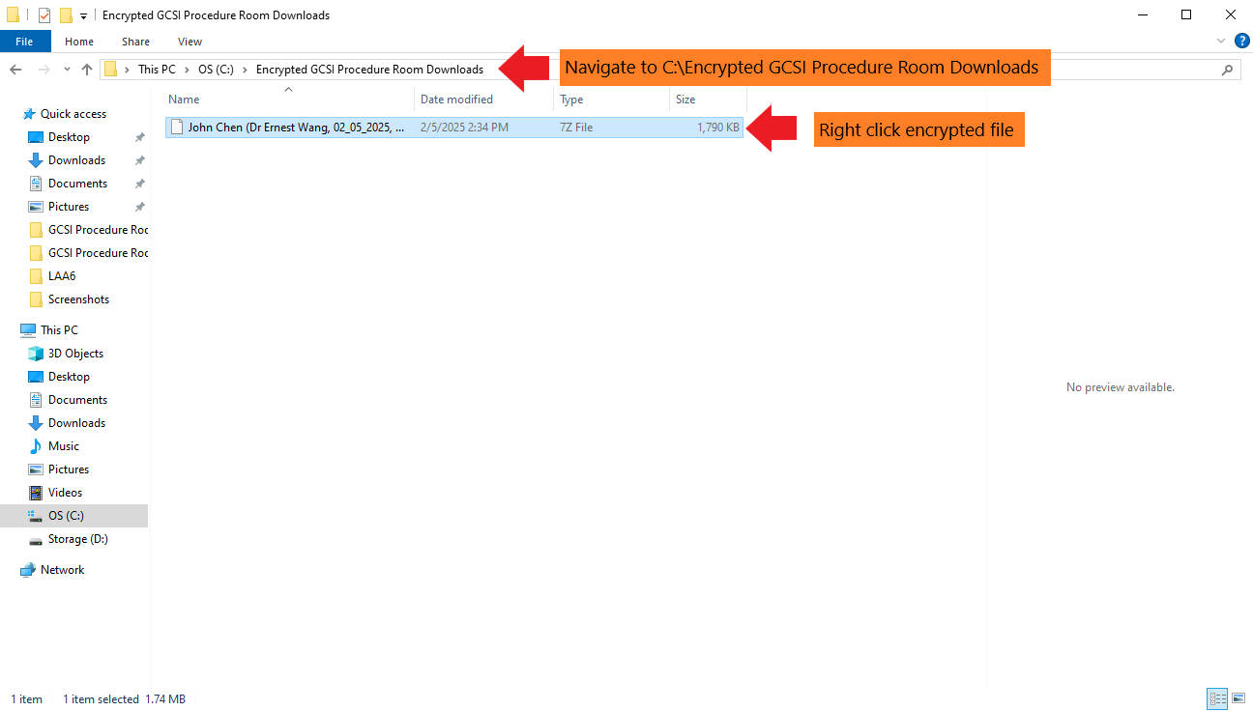

*Figure 54*: Open “C:\Encrypted GCSI Procedure Room Downloads”

* Select “Show more options” (only if you are on Windows 11), select “7-Zip”, select “Extract Here”, and enter the appropriate password (password is determined by what is written in the “real_time_encrypt.ps1” file from Section 1, Step 3) (see Figures 55-56).

*Figure 55*: Extract files using 7-Zip

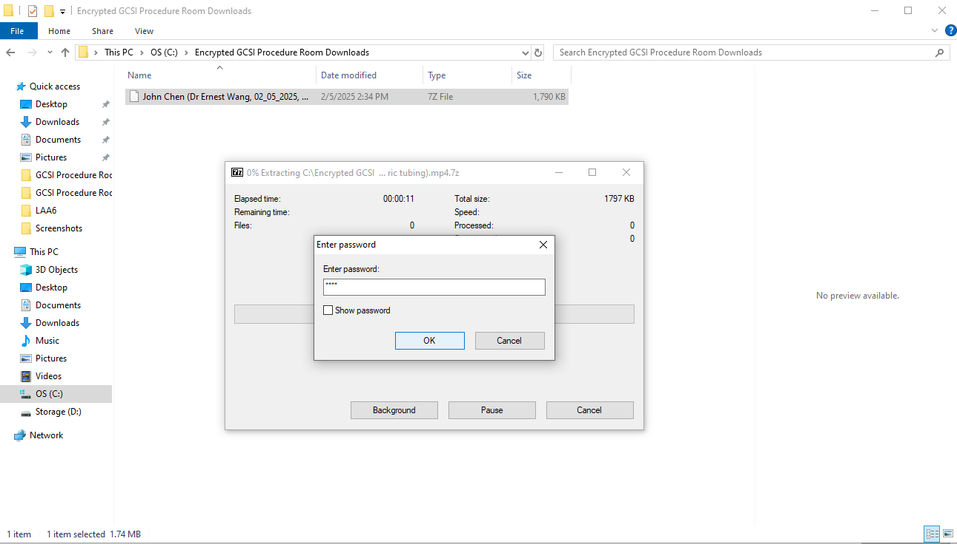

*Figure 56*: Enter encryption password

Double-click to open the unzipped file (see Figure 57).

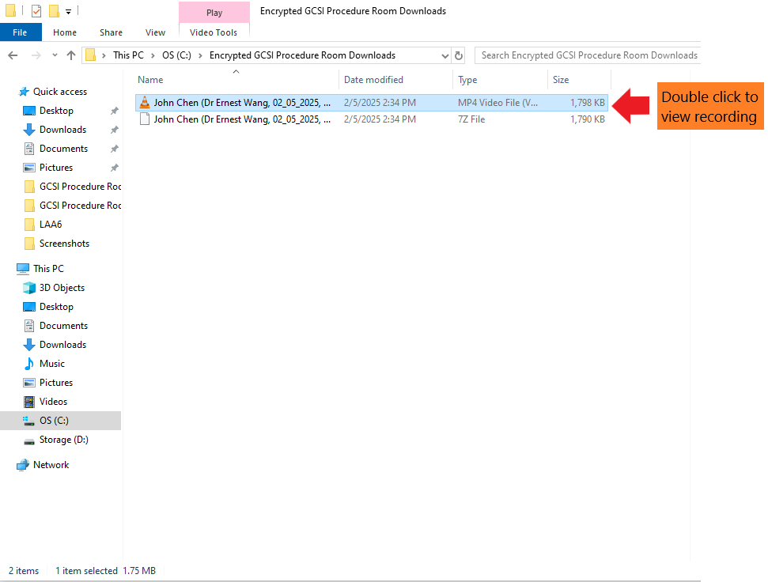

*Figure 57*: Open unzipped file

**Step 3: Share student recordings with facilitators**

At the end of each day of recording, move all unzipped files to an encrypted USB drive. **Delete all unzipped files from “C:\Encrypted GCSI Procedure Room Downloads**.

Plug the USB into a computer with access to GCSI’s shared drive. Upload files into a folder that facilitators have access to and notify them that the recordings are available (see Figure 58).

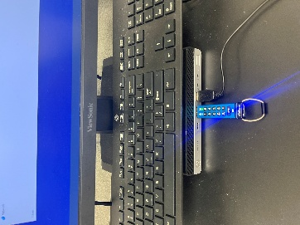 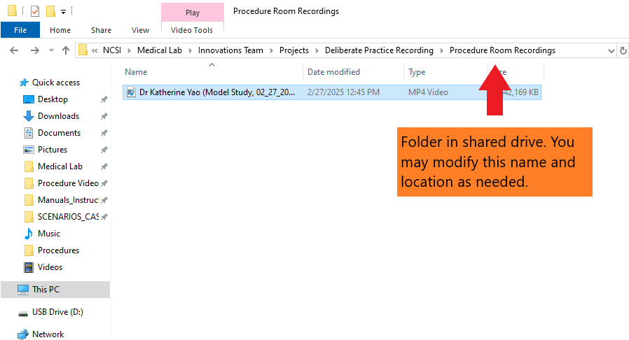

*Figure* *58*: Plug USB into computer with shared drive access and upload to shared folder

**Section 4: Administrators (GCSI technicians) - troubleshooting tips**

**Introduction:**

This section provides troubleshooting tips for administrators (GCSI technicians) on problems during recording system setup.

**Troubleshooting tips:**

* If camera streams are black or not displaying, try removing and re-adding the video sources
* If recordings have no sound, try modifying the “Mic/Auxiliary Audio” in OBS Audio settings
* If recordings have no sound even after modifying the “Mic/Auxiliary Audio” in OBS, try modifying the default microphone in the browser settings
* If PowerShell is throwing an error or video files are not being encrypted, ensure that the folder paths in “real_time_encrypt.ps1” are correct and that all folders being referenced exist

**Section 5: Students**

**Introduction:**

This section provides instructions for students to use the recording system.

**Student instructions:**

1. Enter information into start page.
2. Set up cameras.
3. Record video on recording page.
4. Upload video.

**Section 6: Facilitators**

**Introduction:**

This section provides instructions for facilitators to use the recording system.

**Facilitator instructions:**

1. Download .mp4 files from email.
2. To view, open in Windows Media Player, VLC, or browser (Chrome, Edge, etc.).